**Project Development Phase**

| **Date** | **12 November 2022** |
| --- | --- |
| **Team Id** | **PNT2022TMID16827** |
| **Project name** | **project - Visualising and predicting Heart disease with an interactive dashboard** |

**Sprint-3**

**Exploring Dataset-** The data set would be explored to find the general trends of the data set.

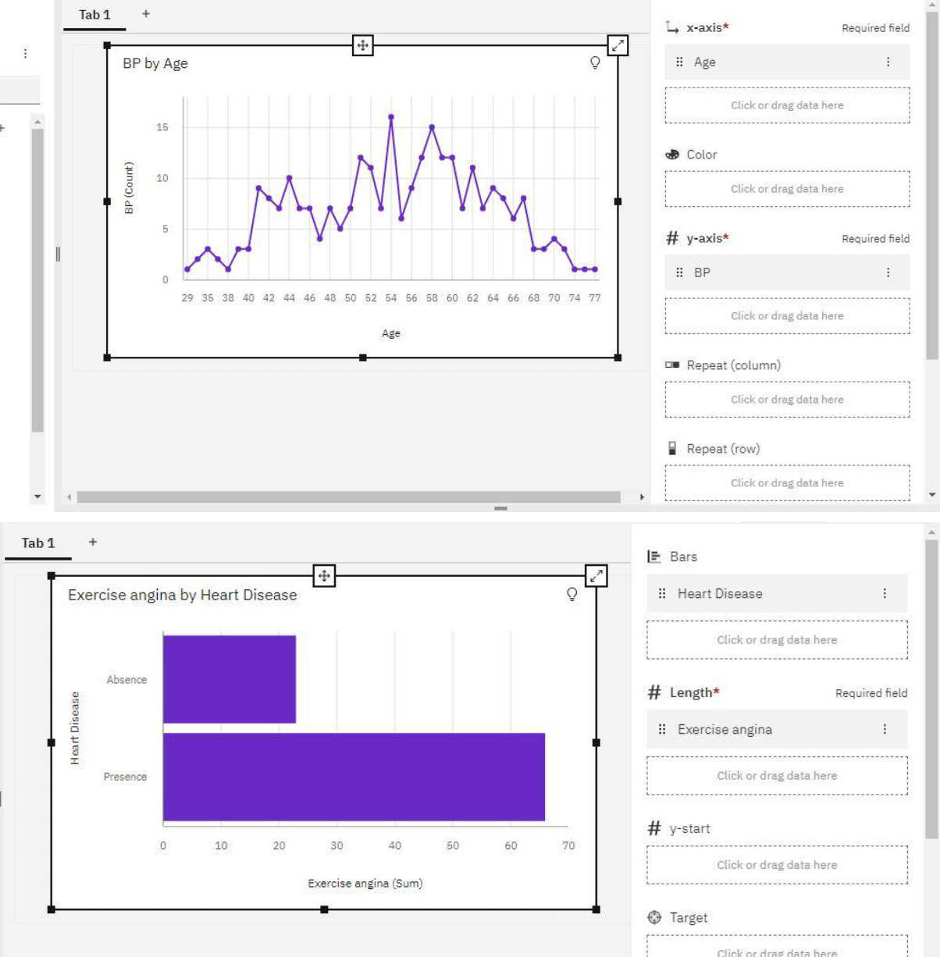

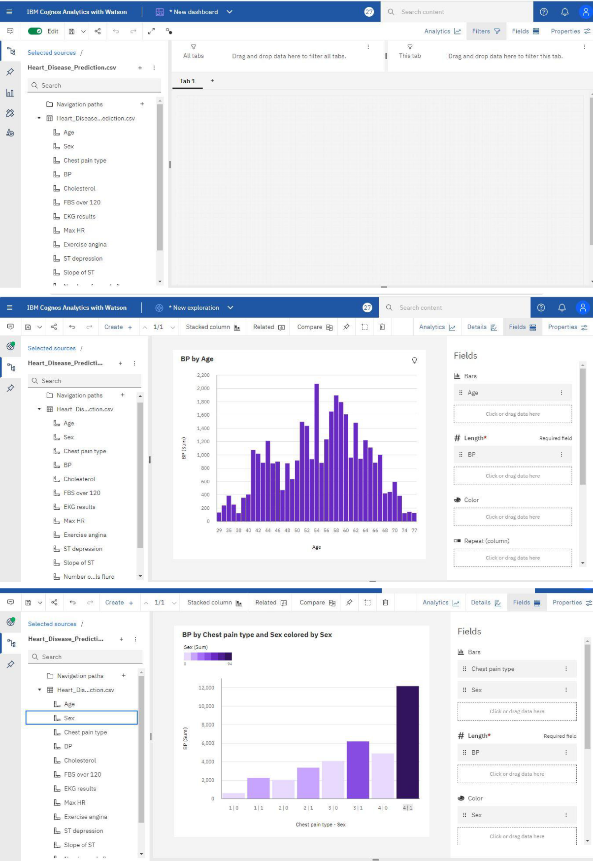

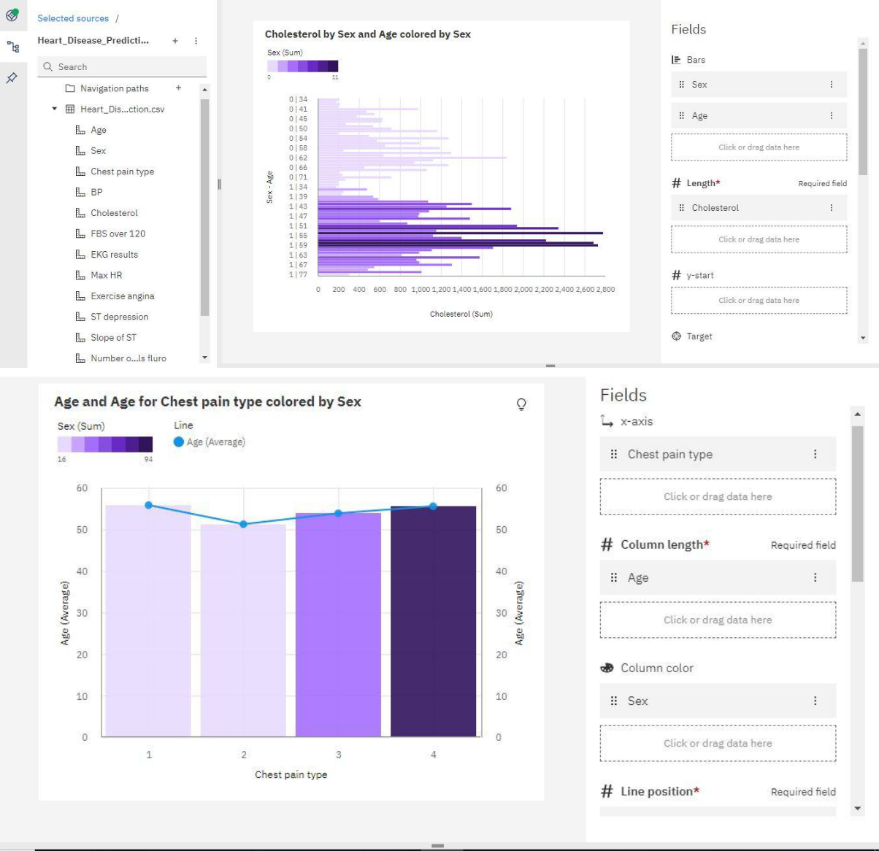

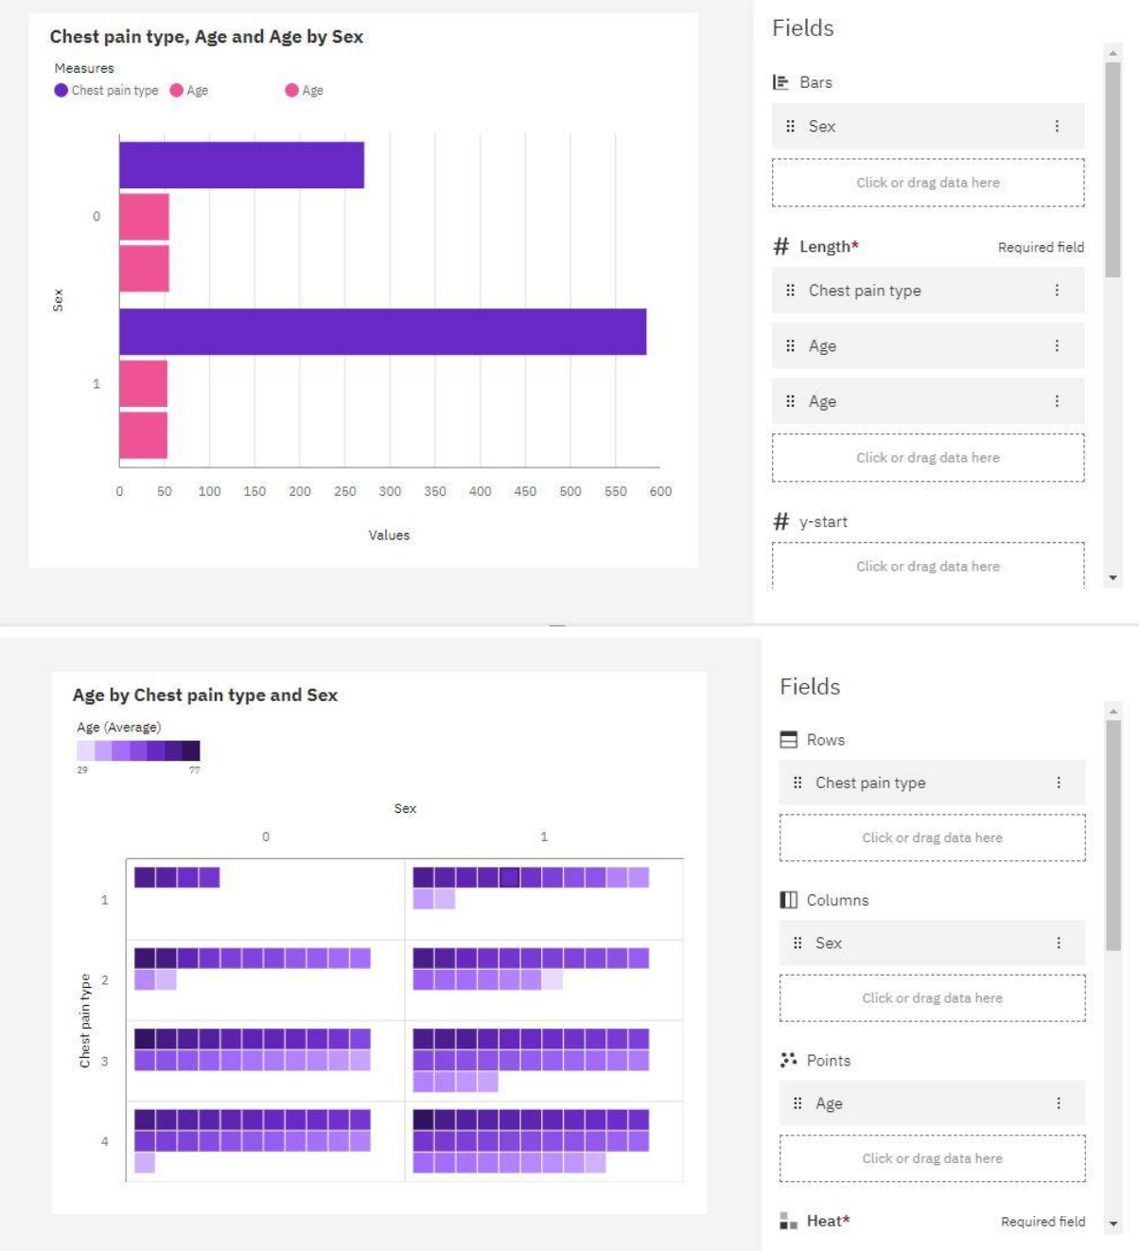

**Working with Dataset -** The Data Should be Evaluated and make useful for the Project.

